PMI Keystone Chapter, PA CHAPTER
FOR SOCIAL GOOD
August 1st - August 31st
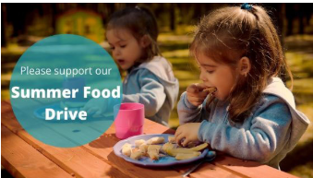
PMI Keystone invites our members to participate in a VIRTUAL “Foodraiser” for the the Central Pennsylvania Food Bank.

To donate simply click HERE, select food to donate & make *payment. *All prices include shipping, handling and service fees.

A VIRTUAL food drive will allow our chapter to help the local community and still keep everyone safe!
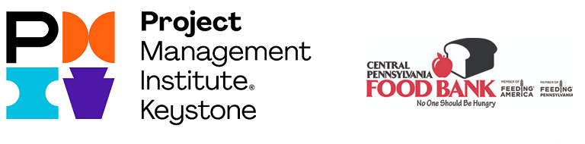
Any questions? Feel free to contact us at pmief@pmi-keystone.org

